Supplement A

Determining Low or Moderate Income Status for the Healthy Food Financing Act Application

This document includes the following sections:
Section | Page Number
Section 1: Determining Low Income Status | 2
Section 2: Documenting Eligibility Status | 5
Section 3: Determining Moderate Income Status | 8
Section 4: Documenting Moderate Income Status | 10

This document was last updated on 11/10/20.
Developed in partnership with Hunger Free Oklahoma.
In order to determine your location’s low income status please complete the following steps:
Step 1: Go to https://www.ers.usda.gov/data-products/food-access-research-atlas/go-to-the-atlas/
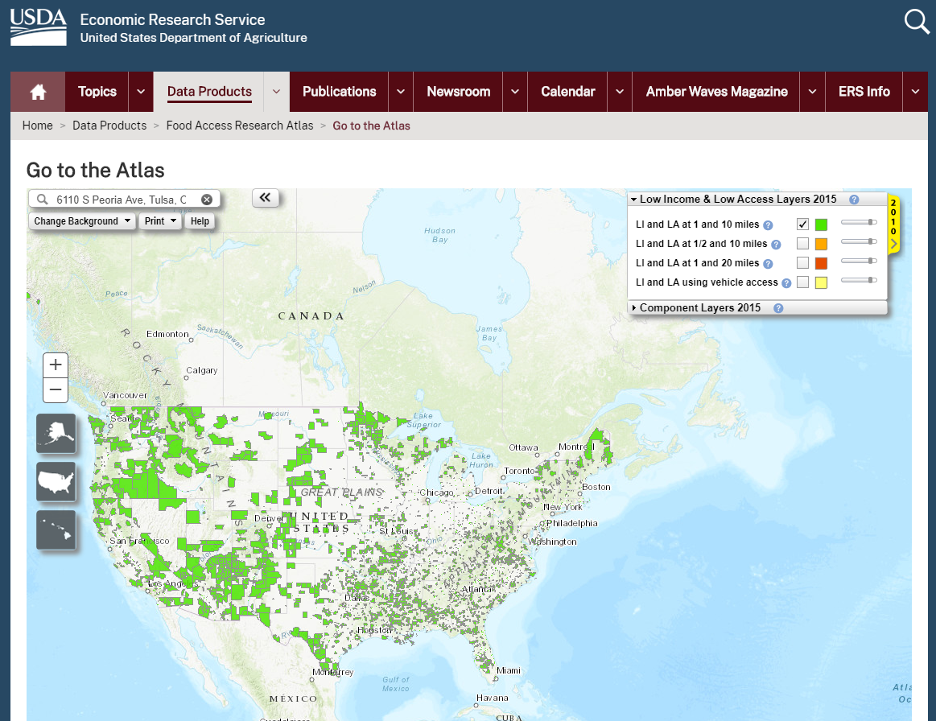
Step 2: Enter the street address of the physical location of the applicant organization in the search bar.

Step 3: Using your mouse select “Component Layers 2015” and the yellow “2010” tab
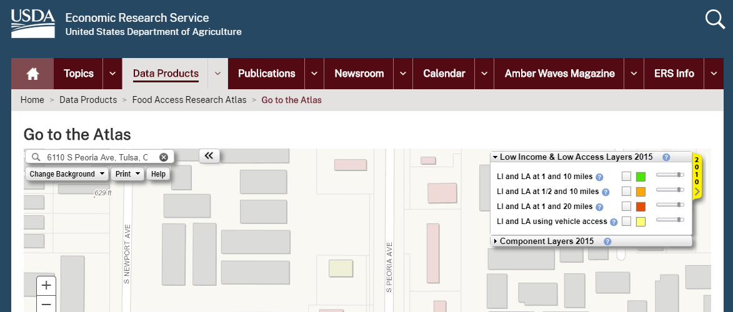
Step 4: Select check box for Low Income within the 2010 column.
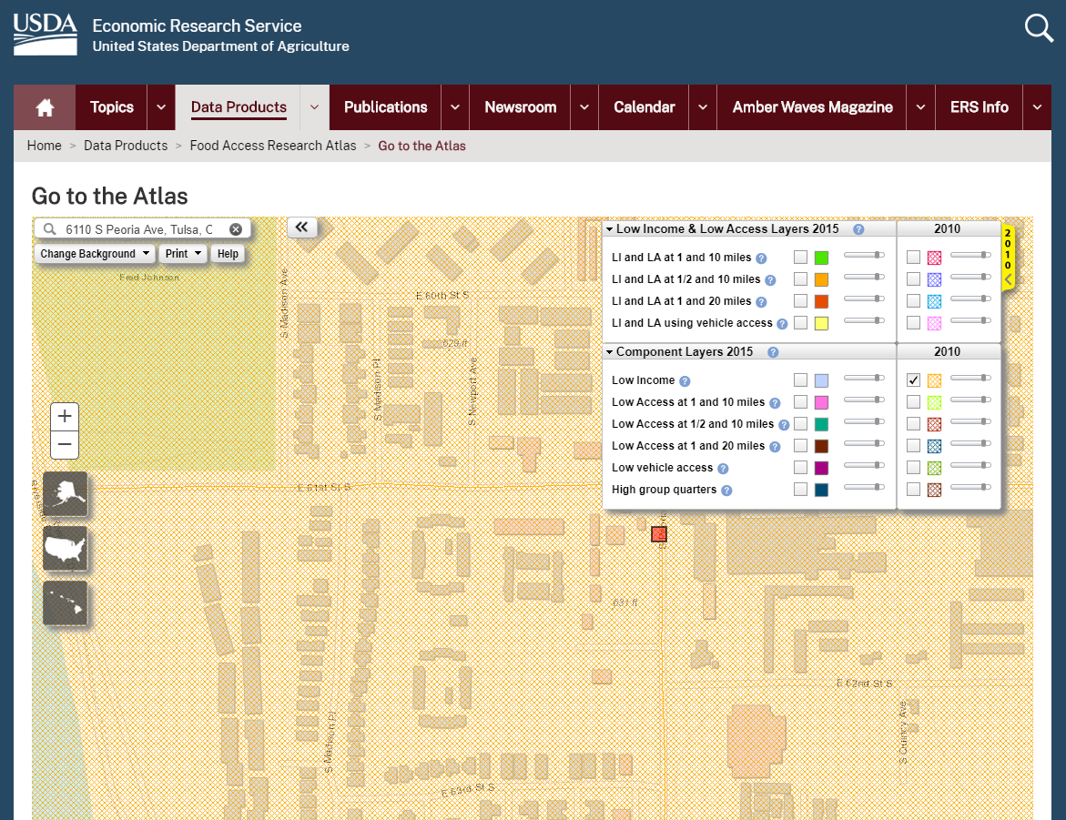
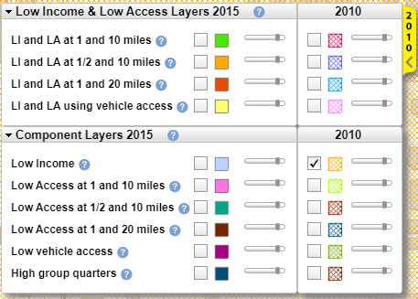

Step 5: If your location, indicated by the red square on the map, is within the yellow cross-hatch shading you are within a census tract that meets the low income requirement of the Healthy Food Financing Initiative statute requirement.
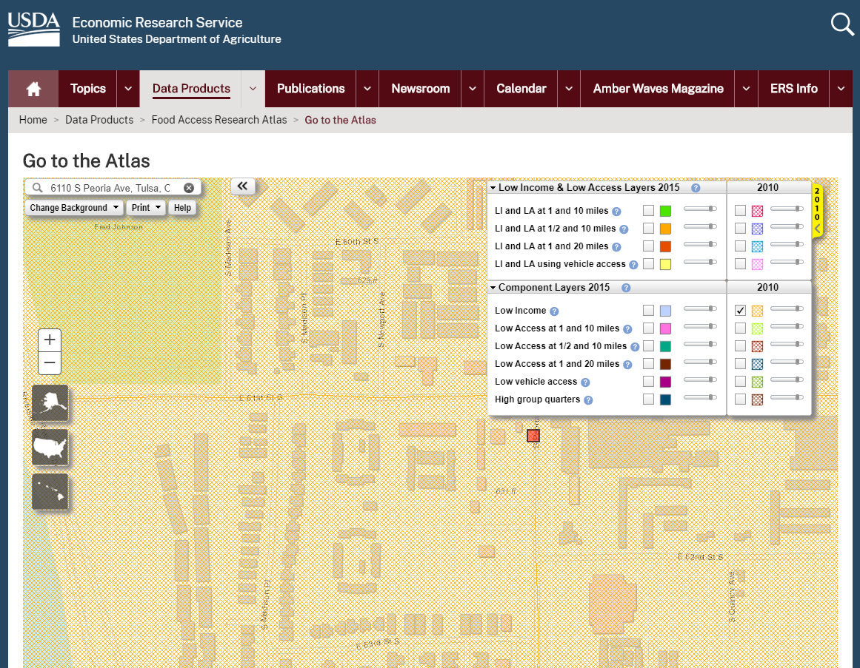

In order to document your eligibility please complete the following steps.
Step 1: Using your mouse, select the red square indicating your proposed location. A pop out bubble (show below) should appear and the applicable census tract should be highlighted in grey.
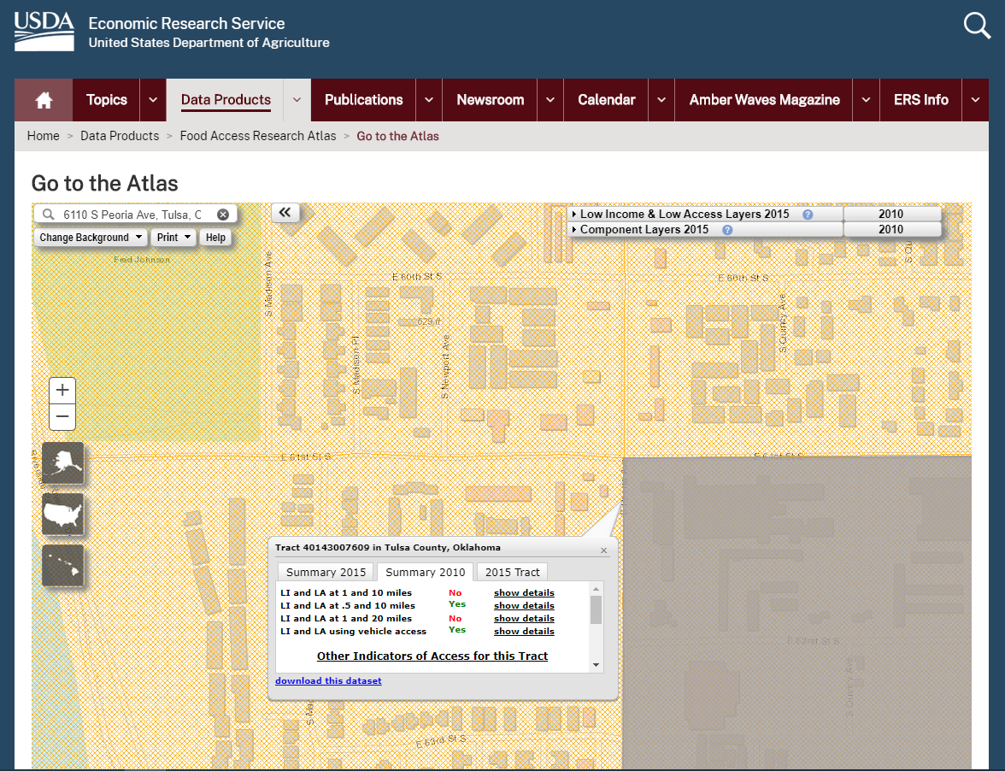
Step 2: In the top right hand corner of the map select “print” and then “Landscape(PDF)”

Step 3: Enter a map title. Select “OK.”
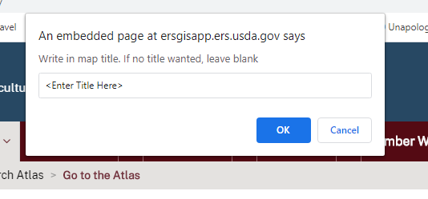

Step 4: Select “Click here to open printable map.” A copy of your map should open in a new window.
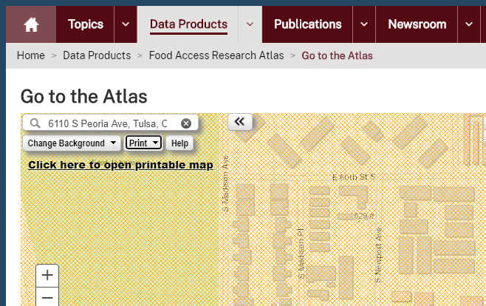

Step 5: Save the Map and attach it to your application for verification.

Step 6: Using the pop out, be sure to include the following information in your application:
- List the Eligible Census Tract (highlighted in yellow)
- Indicate if your site is LI and LA at any of the distances included (highlighted in green)
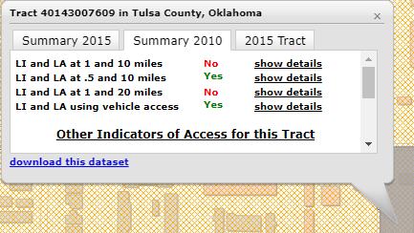

Step 7: Download the data set and attach it to your application.

If your location does not meet the requirements for low income status please complete the following steps to determine if your location meets the requirements for moderate income.
Step 1: Go to https://geomap.ffiec.gov/FFIECGeocMap/GeocodeMap1.aspx
Step 2: Enter the street address of the physical location of the applicant organization in the search bar. Select “Search.”
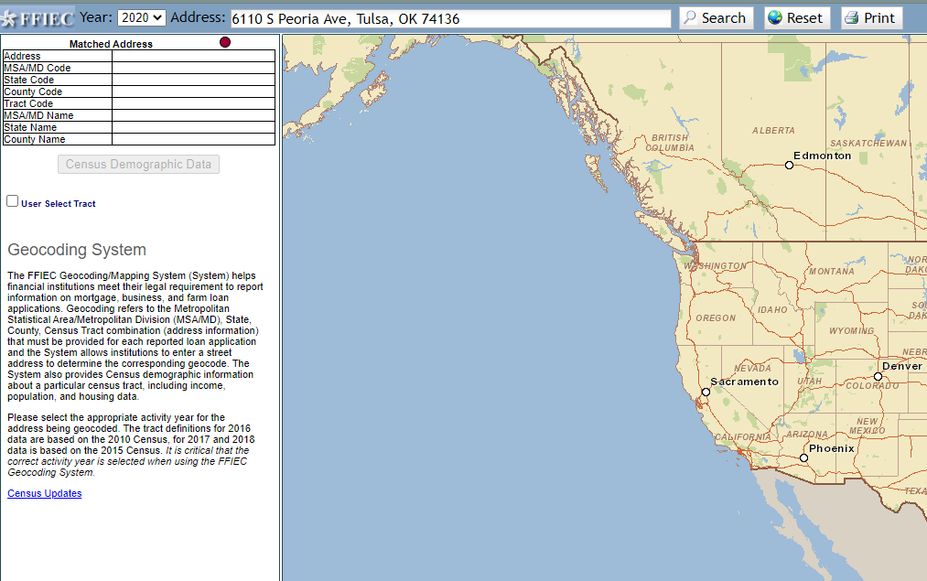

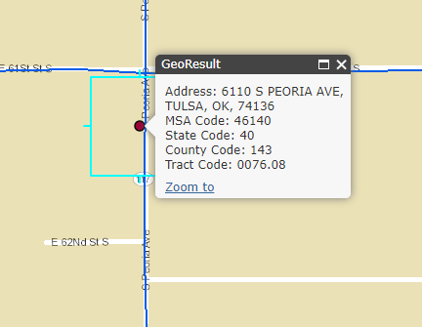
Step 3: Select the black circle indicating your location.

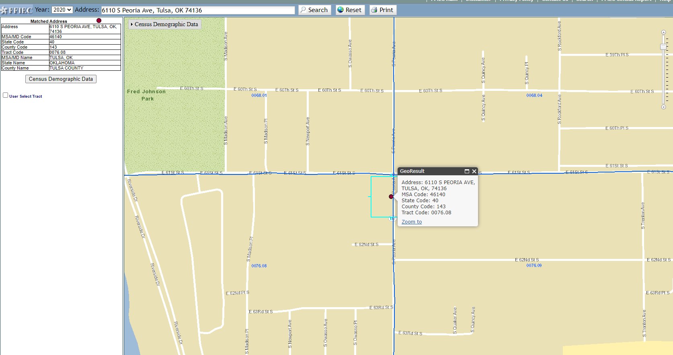
Step 4: Select “Print” at the top of the map.

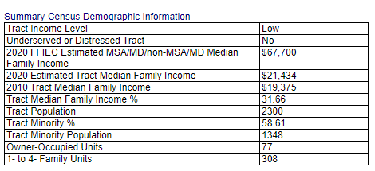
Step 5: A Map with four tables should populate in a new window. Scroll down to the table titled “Summary Census Demographic Information.” If the top row of the right hand column (highlighted in yellow) indicates “Low” or “Moderate” your location meets the criteria.

Please complete the following steps to document
moderate income status.
Step 1: Right click the window and select print. Print the Document to a PDF and attach to your application. In your application, be sure to include the census tract information (highlighted in green) which can be found below the map image on your saved PDF.
